
SHIRE HIGHLANDS EDUCATION DIVISION
2026 MALAWI SCHOOL CERTIFICATE OF EDUCATION MOCK
EXAMINATION

MAP READING AND PHYSICAL GEOGRAPHY
Subject Number: M073/I
Tuesday, 24th March Time Allowed: 3 Hours
8:00- 11:00 am
PAPER I
Instructions
Question  Number | Tick if  answered | Do not write in  These column
1
2
3
4
5
TOTAL
- This paper contains 10 printed pages. Please check.
- This paper has five questions. Answer the questions in the spaces provided.
- This paper has two sections, A and B.
- Section A comprises of three questions and candidates must answer all the three questions.
- Section B comprises of two questions and candidates must answer one question only.
- Write your Name on top of the question paper.
- In the table provided on this page, tick against the question numbers you have answered.

SECTION A (75 marks)
- a. (i) Define local wind
______________________________________________________________________________________________________________________
(1 mark)
(ii) Give any two characteristics of local winds
______________________________________________________________________________________________________________________
(2 marks)
(iii) Describe how a Sea breeze is formed
________________________________________________________________________________________________________________________________________________________________________________________________________________________________________________
(4 marks)
(iv) Describe any tow importance of sea breezes
________________________________________________________________________________________________________________________________________________________________________________________________________________________________________________
(4 marks)
b. (i) Describe any two conditions necessary for the formation of rainfall
________________________________________________________________________________________________________________________________________________________________________________________________________________________________________________
(4 marks)
(ii) Describe how frontal rainfall is formed
________________________________________________________________________________________________________________________________________________________________________________________________________________________________________________
(4 marks)
c. (i) Give any two characteristics of volcanic mountains
________________________________________________________________________________________________________________________
(2 marks)
(ii) Mention any two ways in which volcanic mountains are important
________________________________________________________________________________________________________________________
(2 marks)
(iii) Give any two problems associated with volcanic mountains
________________________________________________________________________________________________________________________
(2 marks)
2. a. (i) What is an “earthquake”? ________________________________________________________________________________________________________________________
(2 marks)
(ii) Explain how faulting causes earthquakes. ____________________________________________________________________________________________________________________________________________________________________________________
(2 marks)
(iii) Mention any two human activities which promote the occurrence of earth tremors. ________________________________________________________________________________________________________________________
(2 marks)
b. (i) Give any two examples of solid precipitation. ________________________________________________________________________________________________________________________
(2 marks)
(ii) State any two characteristics of orographic rainfall. ________________________________________________________________________________________________________________________
(2 marks)
c. Figure 1 is a world map showing distribution of air masses.
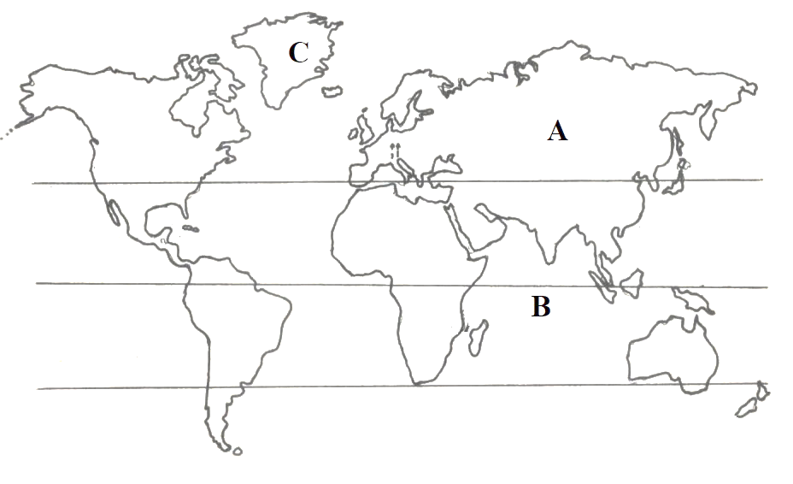
- Name the air masses found in regions labelled B and C
B ____________________________________________________ 1 mark
C ____________________________________________________ 1 mark
- State any two differences between the air masses found in regions labelled A and B. ________________________________________________________________________________________________________________________
(2 marks)
- Account for the absence of rainfall in regions lying under air mass C. ____________________________________________________________________________________________________________________________________________________________________________________
(3 marks)
d. Figure 2 is a diagram showing fronts. Use it to answer questions that follow:
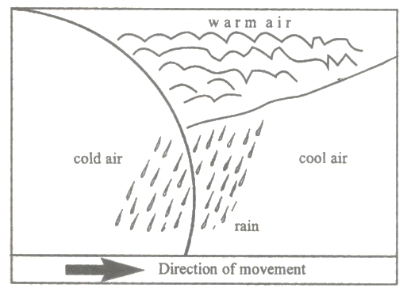
Figure 2
- Name the type of front. ___________________________________________________________
(1 mark)
- Describe the formation of occluded
____________________________________________________________________________________________________________________________________________________________________________________________________________________________________________________
(4 marks)
- What type of weather is determined by high pressure areas? _____________________________________________________ (1 mark)
- Mention any two factors that affect air pressure. __________________________________________________________________________________________________________________________
(2 marks)
3. a. (i) Give the names of two land masses which saves as geological evidence in the theory of continental drift. __________________________________________________________________________________________________________________________
(2 marks)
(ii) Mention two things that influence continents and ocean floors to move over the asthenosphere? __________________________________________________________________________________________________________________________
(2 marks)
(iii) Mention any two environmental and resource influences of faults and block mountains. ________________________________________________________________________________________________________________________
(2 marks)
(iv) Explain any two-evidence supporting the concept of seafloor spreading. ____________________________________________________________________________________________________________________________________________________________________________________________________________________________________________________
(4 marks)
b. Figure 3 is a diagram of a plate boundary. Use it to answer the questions that follow:

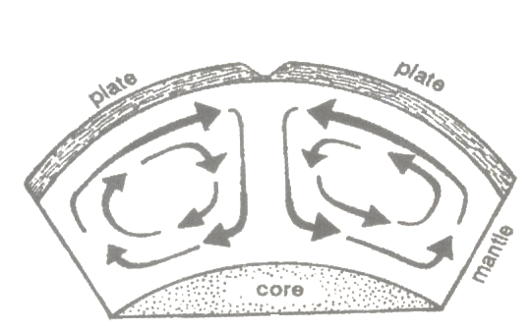
Figure 3
(i) Name the type of plate boundary. _____________________________________________________________
(1 mark)
(jj) Mention any two geological features which are formed at this boundary. __________________________________________________________________________________________________________________________
(2 marks)
c. (i) Explain any two human causes of climate change. ____________________________________________________________________________________________________________________________________________________________________________________________________________________________________________________
(4 marks)
(ii) Explain any two adaptation measures to climate change. ____________________________________________________________________________________________________________________________________________________________________________________________________________________________________________________
(4 marks)
(iii) Give any two reasons why desertification is becoming a threat to Malawi. ____________________________________________________________________________________________________________________________________________________________________________________________________________________________________________________
(4 marks)
SECTION B (25 marks)
4. a.
(i) State one characteristic of equatorial climate. _____________________________________________________________
(1 mark)
(ii) Describe the type of vegetation which grow in equatorial climate. _____________________________________________________________
(1 mark)
(iii) Name any two areas in Africa which experience the equatorial climate ____________________________________________________________________________________________________________________________
(2 marks)
(iv) Explain any two climatic characteristics of the equatorial climate ________________________________________________________________________________________________________________________________________________________________________________________________________________________________________________________
(4 marks)
b. (i) Why does the government of Malawi spend money on refuse disposals? Give any two reasons. ____________________________________________________________________________________________________________________________________________________________________________________________________________________________________________________
(4 marks)
(ii) Describe how an aneroid barometer works
________________________________________________________________________________________________________________________________________________________________________________________________________________________________________________________________________________________________________________________________________________________________________________________________________________________________________________________________________________________________________________
(6 marks)
(iii) Explain how igneous rock can change to sedimentary rock. _________________________________________________________________________________________________________________________________________________________________________________________________________________________________________________________________________________________________________________
(4 marks)
(iv) Why are sedimentary rocks stratified. __________________________________________________________________________________________________________________________
(2 marks)
(v) To which group do the cumulonimbus clouds belong. _____________________________________________________________
(1 mark)
5. a. (i) Explain how global warming affect the amount of rainfall in an area. ____________________________________________________________________________________________________________________________
(2 marks)
(ii) Describe any two signs which show that a tropical cyclone is approaching. ____________________________________________________________________________________________________________________________
(2 marks)
(iii) What type of weather is associated with the arrival of an eye during a tropical cyclone? ____________________________________________________________________________________________________________________________
(2 marks)
(iv) Write any two effects of the ITCZ as wind blows into low pressure zone. ________________________________________________________________________________________________________________________________________________________________________________________________________________________________________________________
(2 marks)
b. Figure 2 is world map. Use it to answer questions that follow:
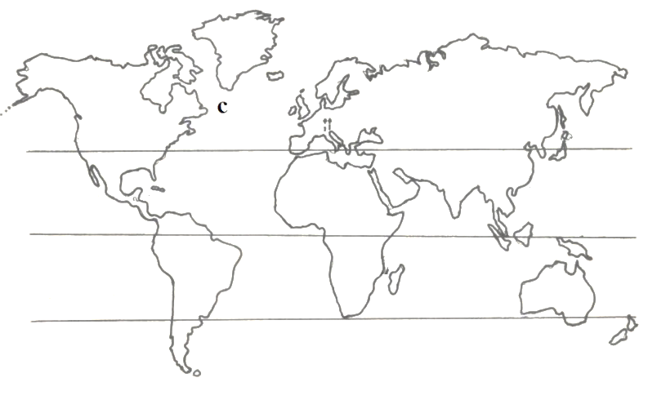
Figure 2
(i) Name the ocean currents that meet at C. ____________________________________________________________________________________________________________________________
(2 marks)
(ii) Explain two effects of the meeting of the ocean currents mentioned in b (i) ____________________________________________________________________________________________________________________________
(4 marks)
The figure below shows a type of vegetation. Use it to answer the questions that follow

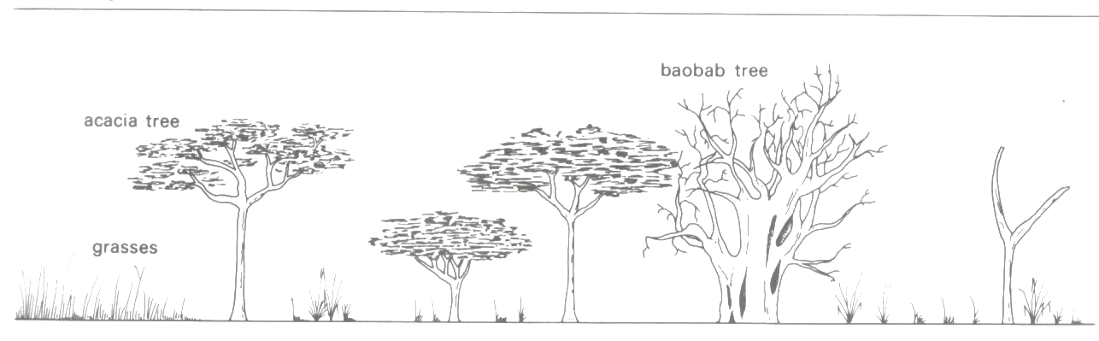
c. (i) Name the type of vegetation shown in the photograph. _____________________________________________________________
(1 mark)
(ii) Describe any two characteristics of the vegetation type named in c (i) ________________________________________________________________________________________________________________________________________________________________________________________________________________________________________________________
(4 marks)
(iii) Name any two countries in Africa where this type of vegetation is found. ____________________________________________________________________________________________________________________________
(2 marks)
(iv) State any two factors which are likely to retard development in the area where this type of vegetation is found. ____________________________________________________________________________________________________________________________
(2 marks)
(v) Explain one reason why desert plants have few or no leaves at all. ____________________________________________________________________________________________________________________________
(2 marks)
END OF THE QUESTION PAPER

